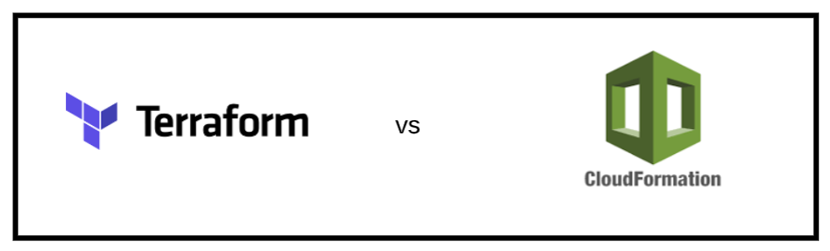

Terraform allows you to control your infrastructure.Terraform uses HCL (HashiCorp Configuration Language), developed to strike a balance between being human readable as well as machine-friendly. Using infrastructure as code this means that the code used can be of a high level to describe and manage infrastructure.

In Terraform, you can run a ‘plan’ step before applying any changes. This step tells you precisely what is going to change and why and also has colours highlighting these changes.

CloudFormation is a tool from AWS that allows you to spin up resources effortlessly. You define all the resources you want AWS to spin up in a blueprint document made in either JSON or YAML. With CloudFormation you are able to see and design your infrastructure with the designer.

When deciding which tool to use , terraform or cloud formation we focused on personal preference in the group and went with what the majority of the group felt comfortable with and with that in mind the group decided that terraform was the best tool to use for setting up the infrastructure of the deployment for the app on of the main reasons we decided to use terraform was that it was easier to use .ts files rather than using cloudformation and .yml files because yaml files are prone to failing when there are indentation errors in the code. Terraform also validates the config file before running it.